- Introduction and Dataset description
This dataset consists of daily weather observations obtained from the National Oceanic and Atmospheric Administration (NOAA), specifically from the Central Park weather station (Station ID: USW00094728).
This dataset description focuses on the weather dataset, which serves as an explanatory variable source in our analysis.

- Data Acquisition
The weather data was acquired from NOAA’s Global Historical Climatology Network – Daily (GHCN-Daily) database.

The station selected is:
Station Name: Central Park, NY
Station ID: USW00094728
Data Frequency: Daily
Time Range Used: January 1, 2023 – December 31, 2023

The GHCN-Daily dataset provides standardized meteorological measurements collected by official monitoring stations.

- Cleaning and Preprocessing steps
- Converted DATE to datetime format
- Filtered data to retain only 2023 observations
- Selected relevant variables: DATE, TMAX, TMIN, PRCP, SNOW, AWND
- Converted measurement units
- Handled missing values using removing
- Engineered additional features:
TEMP_AVG = (TMAX + TMIN)/2
RAIN_FLAG = PRCP > 0
HOT_DAY = TMAX > 85°F
COLD_DAY = TMIN < 32°F
WEEKDAY / WEEKEND

- Variables Description
The following key variables were retained for analysis:
Variable | Description | Unit (Original)
DATE | Observation date | YYYY-MM-DD
TMAX | Daily maximum temperature | Tenths of ˚C
TMIN | Daily minimum temperature | Tenths of ˚C
PRCP | Daily total preciptation | Tenths of millimeters
SNOW | Daily snowfall | Millimeters
AWND | Average wind speed | Meters per second

- Exploratory Data Analysis (EDA)
5.1 Temperature Trend
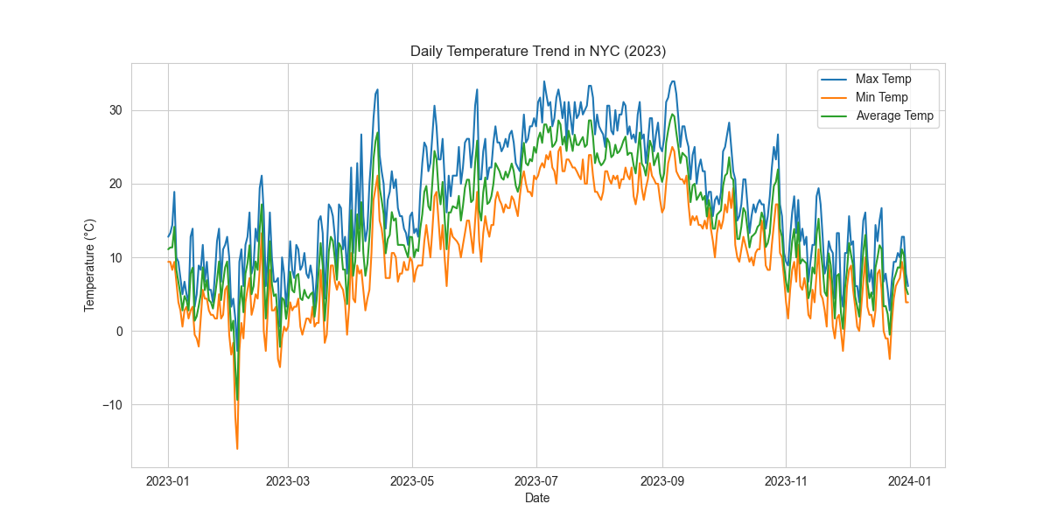
5.2 Precipitation Distribution
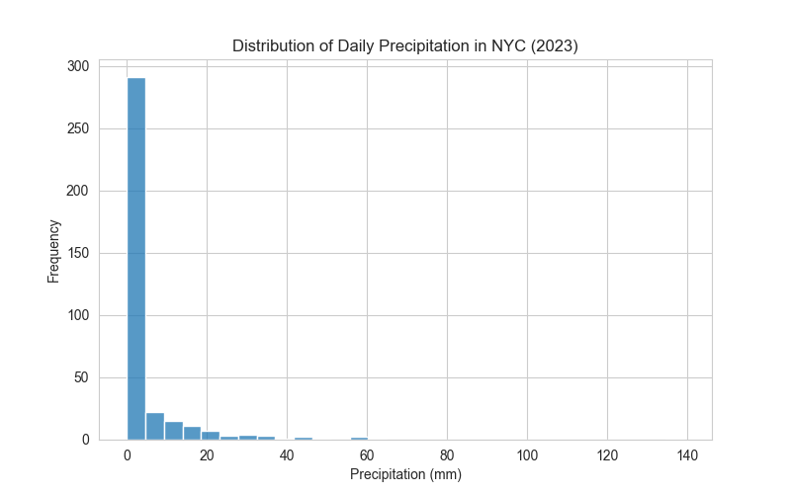

5.3 Wind Speed Distribution
